ITEC3250

Assignment 5

100 pts

Due 10/29

Dr. Jonathan Jenkins
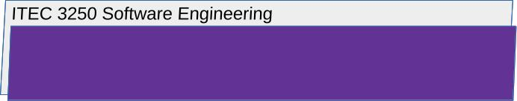

4 Part 1: Dependable Software Systems, with Textbook Chapter 10

Answer the Following Questions

- Choose a mobile or desktop software application you have access to or can research, and then
briefly explain one way that this application does or could fail one of the dependability properties (reliability, safety, security, availability, resilience)
Then, argue how redundancy or software diversity could be used to help mitigate the failure

For a simple example, a mobile application might fail a security requirement by not implementing security services that prevent an attacker from intercepting and reading messages transmitted through a carrier network

- One way the application Discord could fail the dependability property of availability is through server outages. If Discord’s servers go down at all due to maintenance, a cyberattack, or any technical issue, the users would not be able to access the app, or there may be delays in logging in, messaging, or voice capabilities. This impacts the app’s availability, preventing users from being able to use the application as expected.

Redundancy could be used to help mitigate the failure by having backup systems in place. For the Discord app, this could mean having multiple servers spread across different locations. If one server farm goes down, that server’s traffic can be redirected to other servers that are still running, ensuring minimal disruption. The user may only experience a higher ping, but the app would continue to function.

5 Part 2: Reliability Engineering, with Textbook Chapter 11

Answer the Following Questions

- Briefly explain what you argue would be one functional reliability requirement and one non-functional reliability requirement of a mobile device application or desktop software application you have access to or can research
Remember that a reliability requirement is one that describes ‘what the system does’ (functional) or ‘what the system must be’ (non-functional) in order to achieve reliability.

- One functional reliability requirement for the Discord app would be its message delivery function. The application must reliably deliver messages between users. This ensures that communication, Discord’s raison d'être, remains timely and effective.
- One non-functional reliability requirement is its availability. Discord should maintain a high level of uptime while minimizing any downtime or service interruptions. This ensures that its users can consistently and reliably access the application.

